S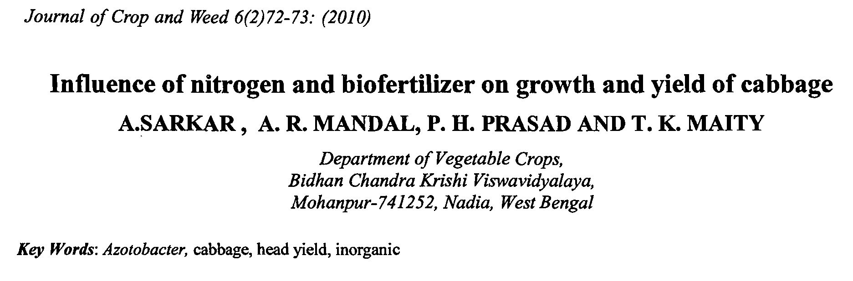
Journal of Crop and Weed 6(2)76-77: (201 0)

Short communication

