*Journal Crop and Weed, 11(Special Issue):127-133(2015)*

**Exploring the feasibility of arecanut based farming systems in augmenting**

**farm economy- a case study in Karnataka, India**

**K. P.VISHWAJITH, P. K. SAHU, B. S. DHEKALE, MD NOMAN AND P. MISHRA**

*Department of Agricultural Statistics*

*Bidhan Chandra Krishi Viswavidyalaya*

*Mohapur-741252, Nadia, West Bengal*

*Received:20-10-2014; Revised: 24-12-2014; Accepted:07-01-2015*

**ABSTRACT**

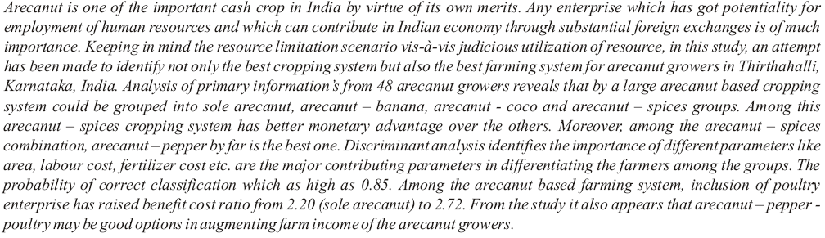

***Keywords***: arecanut, cropping system, discriminant analysis, farming system