*Journal Crop and Weed, 11(Special Issue):124-126(2015)*

**Effect of crop geometry on yield and quality of seed**

**and essential oil of dill (*Anethum sowa*)**

**A. BHATTACHARJYA, 1N. CHATTOPADHYAY, J. K. HORE AND W. SIDDIQUI**

*Institute of Horticulture Technology, Greater Noida-201309, New Delhi*

*1AICRP on Agroforestry, RRS, BCKV, Jhargram, W.B*

***2****Dept. of Spices & Plantation Crops, BCKV, Mohanpur, Nadia*

***3****Bihar Agricultural University, Sabour, Bhagalpur, Bihar*

*Received : 14-08-2014; Revised : 20-12-2014; Accepted : 02-01-2015*

**ABSTRACT**

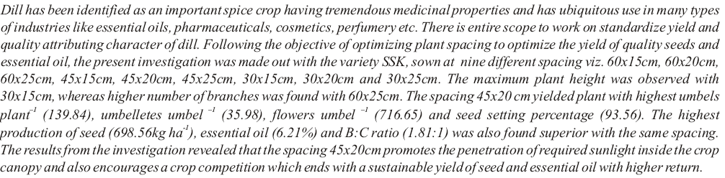

***Keywords*** : Dill, essential oil, spacing, yield.