*Journal Crop and Weed, 11(Special Issue):106-112(2015)*

**Effect of irrigation and sulphur on growth, yield and water use of summer**

**sesame (*Sesamum indicum* L.) in New Alluvial zone of West Bengal**

**A. M. PUSTE, 1B. RAY PRAMANIK, K. JANA, S. ROY AND 2T. SUNANDA DEVI**

*Department of Agronomy, Faculty of Agriculture,*

*Bidhan Chandra Krishi Viswavidyalaya, Mohanpur - 741 235, Nadia, West Bengal.*

*1Directorate of Agriculture, Government of West Bengal.*

*2AICRP on Soybean (ICAR), CAU, Imphal-795 004, Manipur*

*Received:15-08-2014; Revised: 13-01-2015; Accepted:15-01-2015*

**ABSTRACT**

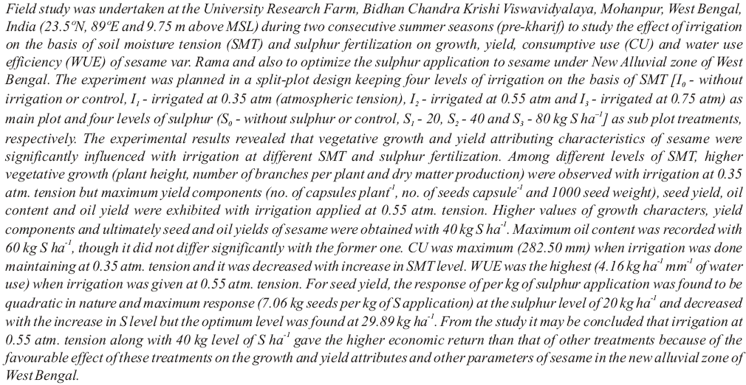

***Keywords*:** Consumptive use, irrigation, sesame, soil moisture tension, sulphur, water use efficiency.